|  |  |
| --- | --- |
| **Team Name** | Aurora Tech |

|  |  |
| --- | --- |
| **Project Title** | KINEFF |

|  |  |
| --- | --- |
| **University** | GhulamIshaq Khan Institute of Technology and Engineering Sciences, KPK |

|  |  |
| --- | --- |
| **City** | Topi, Swabi |

|  |  |
| --- | --- |
| **Project Completed (in percentage)** | 90% |

**Team Members Details:**

|  |  |  |  |
| --- | --- | --- | --- |
| **S#** | **Name** | **Mobile Number** | **Email Address** |
| **1.** | Muhammad Asjad | 03238553333 | [asjad_2004@hotmail.com](mailto:asjad_2004@hotmail.com) |
| **2.** | Huymayun Haroon | 03224390947 | [humayunharoon@gmail.com](mailto:humayunharoon@gmail.com) |
| **3.** | Danish Sajwani | 03022283282 | [danishsaj@yahoo.com](mailto:danishsaj@yahoo.com) |
| **4.** | Ahmad Masood | 03216978893 | [ahmad.m.salahuddin@gmail.com](mailto:ahmad.m.salahuddin@gmail.com) |

**Hardware Used:**

* *Kinect for Xbox 360*
* *PC running WindowsXP or higher,*
* *Reasonable size Display orProjector (for deployment in classrooms).*

**Software Used:**

|  |  |
| --- | --- |
| Software Tools, Frameworks and API’s | |
| **Tool/Technologies** | **Usage In our Project/Description** |
| * Microsoft Visual Studio 2010 Professional | Our IDE for all the development and coding |
| * C# with Microsoft .NET Framework 4.0 | For most part in our project the programming language used will be C#. |
| * Microsoft Kinect for Windows SDK 1.0 Beta2 | NUI API provided access to which will provide us with access to raw stream and skeletal data of the user. This will form the basis of the NUI our project deploys. |
| * Microsoft XNA Framework 4.0 | Used for 3D development of Real and immersive interactive virtual environment. |
| * Farseer Physics Engine | A physics engine used Along with XNA 4.0 to implement real world physics on virtual object |
| * Windows Presentation Foundation | For implementing the GUI in our project |
| * Bing Maps (formerly Virtual Earth) AJAX Control 6.3 and Bing Map 3D | Used for History module. |
| * Unity-3D game Engine | Used for 3D rapid prototyping and development of our ideas. To our knowledge. No Microsoft product offering similar features and capabilities exist. |
| * Kinect Toolbox | For added features, such as gesture recognition with precision Kinect Open sourceToolbox is used. |

# Project KINEFF-detailed report

## Project Abstract:

Our Software, KINEFF, is an amalgamation of multiple Microsoft and open source technologies, welded together expertly to provide an application which supplements the completion of one the millennium development goal [MDG], *Achieving universal primary education.* It is a modular software suite, making use of Microsoft Kinect’s revolutionary depth sensing and body tracking features to aid school teachers of our country at dispensing education in a better and more effective manner. It features many applications which help stimulate student interest and accelerate understanding among them, ensuring *enrollment & completion of primary education* [sub-clause of the MDG], and benefitting students and teachers alike. KINEFF is primarily designed and targeted towards low-budget schools where expert teachers and basic facilities are missing. KINEFF aims to provide a viable alternative for these basic requirements.

# Executive Summary:

Team Aurora’s entry for Microsoft Imagine Cup 2012 revolves around alleviating the world’s problem of *Achieving Universal Primary Education,* which is one of the millennium development goals. We had been experimenting with Microsoft Kinect’s SDK since the day it was released and developed multiple simple applications to test out its effectiveness and realize the possibilities it offers. When we decided to participate in Microsoft’s Imagine Cup, considering this year’s theme, the issue for education in a developing country like Pakistan deemed most important to us.We researched institutions in our locality and found a series of very pressing issues, which we recognized can be resolved with a mix of software design and utilizing Microsoft Kinect’s natural user interface. Coincidently it was a perfect fit for our cause.

Our software is a suite of applications, designed and developed specially to be used in tandem with Kinect’s NUI (Natural User Interface). The natural gestures allow even a computer novice to reap the benefits of our application wholly.

For years, teaching has been a difficult profession: finding ways to elucidate concepts in the best possible manner, and also especially for people with physical limitations due to old age or disabilities. There are a lot of people with extraordinary teaching skills, but are hampered by physical limitations due to a disability.

The applications we have designed are tailor-made to suit the needs of these educators, to augment their teaching needs. Our research indicated that in majority of the schools in Pakistan, students were losing interest in science subjects because they were unable to grasp concepts and a lot of schools lack the lab facilities which are usually in place as an aid to help students grasp these concepts. Our applications allow teachers to explain these concepts using interactive models and simulations, utilizing Kinects NUI in the process and making things very simple for the end user. The applications also allow simulation of real world lab experiments in a virtual environment, making it feasible for these schools to effectively teach students at a cost effective price.

All these things make lives for the teachers easier and their teaching effort more productive, while side by side elevating and maintaining the interest of students at school, which is very important, since one of the prime reasons for such high illiteracy levels is drop-outs due to loss of interest.

# Problem on Focus

It has been over a decade since mankind has entered the 21st century, technology has made access to information even easier than spreading jam on a slice of bread and making a sandwich; that visionaries are talking about the internet as a replacement for universities as source of learning in the near future.

But the importance of teachers, especially in the primary years of a person, is of paramount importance, which usually goes unnoticed. Teachers contribute to society in manners which people don’t realize, unless they actually stop for a moment and think about it. These teachers shape lives, inspire individuals, act as role models and transform children into mature and responsible beings.

For years, teaching has been a difficult profession: finding ways to explain concepts in the best manner that can capture the attention of a young curious mind, and also especially for people with physical disabilities. There are a lot of people with extraordinary teaching skills, but are hampered by physical limitations due to age or a certain disability. Every person’s contribution to society matters and we want to ensure that everyone can contribute to their fullest.

Case Study: We visited a primary school and college in our vicinity at Taxila, Pakistan. The visit revealed several problems that the institute faced, and after further research, happens to be some common problems among many institutions. We recognized that:

* Aged educators and those with physical disabilities have a hard time teaching and delivering lectures.

**Explanation**: Delivering effective lectures involves many activities such as making use of the white board for expressing ideas, navigating and interacting with digital content in case of multimedia aid to lectures, etc. These all activities become quite a tedious everyday task for teachers who are aged or have some sort of physical difficulty.

* A major proportion of students seem to lose interest in science and other subjects quickly and find them dull and boring. This is because they have trouble grasping basic concepts of physics, chemistry and mathematics. Or either due to lack of communication between students and teachers.
* The students who have trouble grasping basic concepts of different subjects (usually science subjects) never opt for the same subjects in higher classes.
* Due to low budgets, many institutes in our country such as this one don’t have any labs or equipment to demonstrate even basic scientific concepts practically to students.

Our mission is to aid all these teachers, using Microsoft’s Kinect technology to be able to teach and deliver lectures in the same manner as normal people do. Also, our secondary purpose is to aid teachers in our country to be able to communicate fundamental concepts of different subjects in a very optimal manner. If these concepts are communicated effectively, a much larger proportion of students will be able to grasp these concepts, in turn also maintaining their interest in said subjects.

It is our understanding that, if these basic problems are dealt with, it’ll help alleviate the problems these institutes are plagued with and augment the education system to achieve the Millennium Development Goal much faster.

# Proposed Solution

## Background:

Gesture-Based and surface-based computing is a new way of interacting with computers that moves beyond the traditional keyboard and mouse experience. It is a natural user interface that allows anyone to interact with digital content the same way they have interacted with physical objects such as photos, paper, and maps their entire life: with their hands, with gestures and by putting real-world objects on the surface.

We have already seen the success of one such product capable of providing such technology; namely **The Microsoft Kinect** (initially designed for Xbox 360) providing **Immersive game technology** in which gestures can be used to control interactions within video games to try and make the game player's experience more interactive and immersive.

Our modules will be utilizing the depth sensing and user’s body tracking capabilities offered by Microsoft Kinect. With the Kinect SDK for windows available, developers can access the Kinect’s video, microphone and depth sensors to build applications that work with the low-level data streams taken in by the hardware. The SDK also allows coders to access some of the more high-level capabilities, such as noise and echo cancellation, and skeletal tracking – which make gesture-navigation in applications possible.

We are confident that by employing several of the modern hardware and software development technologies like MS Kinect or VS 2010, we would be able to solve most of the identified problems that educational institutes of our country face.

## Overview of solutions to the identified Problems:

Subproblem-1 - Aged educators and those with physical disabilities have a hard time teaching and delivering lectures.

Solution: NUI deployed throughout our solution will allow use of hand gestures to navigate and interact with our application. Thus solving most of the problems they face. The ‘interface is you’ remains the maxim for each of the modules we have implemented in our solution.

Subproblem-2 - A major proportion of students seem to lose interest in science subjects quickly, because they cannot grasp concepts of physics, chemistry and mathematics. Educators fail to capture the minds of young students.

Solution: Use of interactive tools and eye catching will create interest and ease burden on educators having a hard time deliveringconcepts involving visualizations. Implemented in modules our solution demonstrates various possibilities in different domains of knowledge, such as Physics, Chemistry, History, and Mathematics. For the time being, our solutions will be focused on solving problems which educators and students of lower classes (Secondary School) face.

Subproblem-3 - Due to low budgets, many institutes don’t have any labs or equipment to demonstrate even basic scientific concepts practically to students.

Solution: Using virtual environments, we can, to some extent augment the experience of real world science laboratories. Students will be able to perform tasks/experiments using virtual objects as they do in natural world.

## Salient Features of our solution:

### User Interface:

Majority of the functions/tasks in our solution will be performed by using a revolutionary gesture based NUI. Our application uses the skeleton tracking to identify the positions of different joints of the user’s body. Using this data the gestures are recognized which are then used in different modules to achieve various tasks.

Let’s now take a brief overview of the project modules and their features.

## *Module A) 3D- Interactive chemistry*

Helps teacher, teach concepts of chemistry through interactive virtual objects. Solves issues that students face while learning concepts of 3-dimension. It features the following:

1. **Chemical Equation Builder**
2. **Atom Structure Builder**
3. **Complex Molecule Builder**
4. **Virtual Chemistry Lab**

## *Module B) Fun with Physics:*

* The students get to feel and experiment for themselves the effects of gravity, magnetism, bounce, object manipulation etc.
* Allows students to select certain modes and then experiment by allowing their creativity to run free.

## *Module C) Virtual White Board*

Helps simulate and extend the features of a physical white board. Educators perform tasks using a gesture controlled UI.

## *Module D) Interactive History lesson presenter*

Helps the teacher in presenting lectures of history in a visual manner, using 3D Bing Maps and a time line.

## Module E) *Math Module*

This application lets the students to experiment with mathematical concepts and take the traditional form of learning mathematics from bookish stuff to a more practical level.

# Detailed design and implementation of solution

## **Module A)** *3D-Virtual Chemistry*

Overview: *This part of the application allows the students to visualize concepts of chemistry in 3-Dimensions. Unlike the traditional methodology of teaching visual concepts using 2D figures or diagram, we take a different approach of using actual 3D models to aid students in the learning process. This makes teaching of concepts involving 3D-visualizations much, more easier for the teacher. It has the following features:*

1. **Chemical Equation Builder**
2. **Atom Structure Builder**
3. **Complex Molecule Builder**
4. **Virtual chemistry lab**

### Technical Details:

**Implementation:**

Presently this module deals with the 3D visualizations in Chemistry. It has the following major features:

1. **Chemical Equation Builder**

The equation builder enables a teacher to construct an equation in a 3D form. The user (teacher) can drag and drop the elements(3D atoms) from a 2D periodic table. The snap shot of this feature can be seen in the project screen shots section followed by a brief explanation.

1. **Atom Structure Builder**

The atom builder goes in a more detailed visualization of an atom. By dragging and dropping,it gives the user options to construct an atom using the basic elements;nucleus, protons, electrons and shells. With these tools a complete detailed atom can beconstructed, for example, the atom of hydrogen with a nucleus, 1 proton associated to the nucleus, and 1 electron in a ring around the nucleus.

1. **Complex Molecule Builder**

The complex molecule builder allows the user to create a 3D model of a molecule using atoms and connectors. This will allow the teacher to demonstrate how the molecule is actually connected in a 3D environment.

The following Activity Diagram also explains this module in detail.

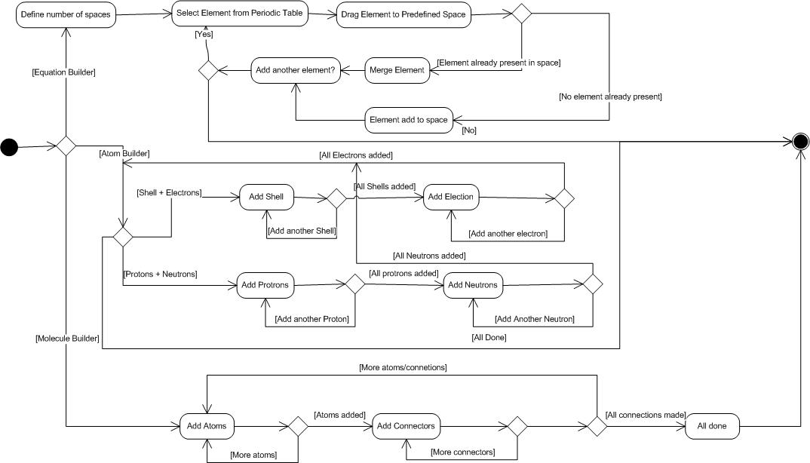

**Software Technologies:**This module is built using the unity 3D game engine, which is an integrated authoring tool for creating 3D video games or other interactive content. It helped us rapid prototyping and development of our ideas. The PhysX (Physics engine) module in unity helped us in creating simulations that depict real world object interaction. The scripting language we used was C#.

**NUI features:** Kinect’s gesture recognition will be completely integrated within this module, allowing full control using the NUI for the user. The user will be able to perform all the required actions such as panning, zooming, interacting using hand gestures.

### Screenshot: refer to appendix A

## **Module B)** *Fun with Physics*

Overview: *This app is used to visually teach student the different concepts of physics. The students get to feel and experiment for themselves the effects of gravity, magnetism, bounce, object manipulation etc. The interface allows students to select certain modes and then experiment by allowing their creativity to run free. For example in gravity mode, objects can be drawn and the effect of gravity on them can be seen. Students have to option to alter gravity values and experience themselves its effect on the on-screen object.*

### Technical Details:

**Implementation:**

This module is subdivided into three sections:

1. **Modes**

There are three modes available to the user; drawing, attraction and object control.When the user (teacher) selects the drawing mode, he/she can draw custom shapes using his/her hands which will transform into physical 2D bodies. The walls limit the bodies in a frame where different bodies can interact with each other. This mode is useful in explaining custom body interactions,such as impact of heavier objects on lighter ones and can be used to make things like see-saw.

The attraction mode introduces attraction between bodies. The first shape that is drawn becomes the attractor, and all the shapes drawn after it, get attracted by the first shape.

In the object control mode the user gets the control of the first body that he/she draws with his/her hands, and all the bodies drawn subsequently can be interacted with using the first body.

1. **Properties**

The property sections allows you to manipulate basic properties of physics such as gravity, restitution etc. When these parameters are selected from the menu, a slider bar is used to set a value of these properties (as it can be seen from the image).

1. **Games**

The user can play games that teach basic concepts of physics. One such game that we have prepared is the simple Kinect Ball Control Game. The user uses his left and a right hand to control a rectangular stick on which a ball is placed. The user has to balance the ball and prevent it from dropping onto the ground.

The following Activity Diagram further explains this module in detail.

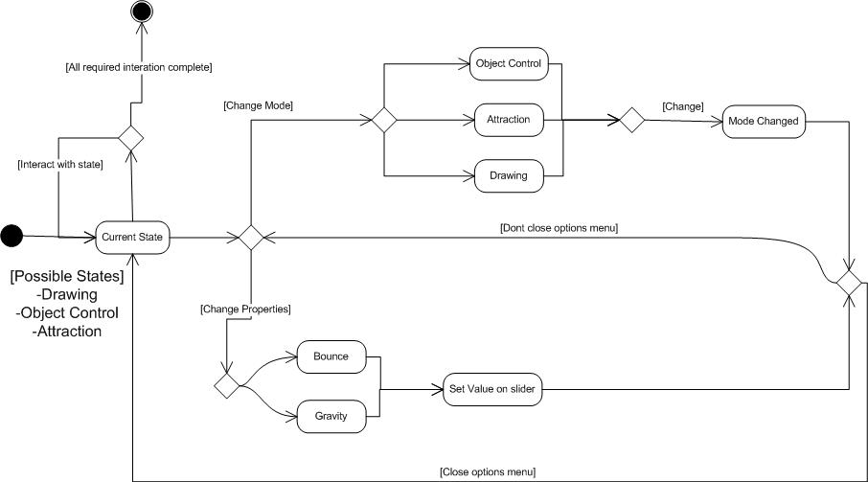

**Software Technologies:**

Fun Physics has been created using the open source Farseer Physics Engine 3.3.

It built on the XNA 4.0 Framework. Our system uses the basic body, fixture and shape creation features etc. along with some texture creation methods. We also use the polygon decomposer techniques such as EarclipDecomposition for custom drawing.

### Features explanation:

**NUI features:** The body making is done using the right hand. The drawing starts when left hand is above the shoulder and ends when left hand is below shoulder level. The selection of an item like the menu panel is done by placing the cursor for a second on the selection item. The slider used to specify the gravity or bounce value uses the right hand swipe left/right gestures to increase or decrease the gravity value.

### Challenges faced:

The major challenge was to understand the architecture of the Physics Engine. There are several functions available that can be used for mapping the raw coordinates to vertices of a body. To analyze all the options and selecting the appropriate one was one of the tasks. Another challenge was the decomposition of the vertices into smaller polygons which was required by all the body making methods. Some of the options available were BayazitDecomposer, CDTDecomposer, EarclipDecomposer etc.

### Solutions to the challenges faced:

For making the physics body we have used CompoundPolygon which takes list of decomposed polygons as an argument. This decomposition is done using EarclipDecomposer. It was used for decomposition since it produces excellent results in the case of custom drawing where the user can draw random shape at any coordinates.

### Screenshot: refer to appendix A

## **Module C)** *Virtual White Board*

Overview: *A class is never complete without a white board, which allows teachers or students can draw/write to depict their ideas and thoughts. The concept of a virtual white board transforms the traditional manual boards in to a technology based digital drawing board, where the user interacts using different natural hand gestures. The user can choose different brushes of different sizes; draw primitive shapes or load/save the drawings.*

### Technical Details:

**Implementation:**

The natural user interface of Kinect is used in this application to provide the user with the facility of drawing on a canvas using gestures.

This module has the following facilities:

1. **Brushes**

The user can make use of the brush tool, with different brush options like solid brush, air-brush, eraser etc, to create custom drawing. The user may also change the brush size.

1. **Shapes**

The user is facilitated in drawing basic shapes such as Circles/Squares/Rectangles etc.

1. **Saving**

The user is given an option to save the images he/she draws and load images that were saved earlier. Currently the user can only save/load images from a single location.

**Software Technologies:**

This module has been created by borrowing some of the features of Kinect Paint project(an open source project). It is a CodePlex project under the Microsoft Permissive License (Ms-PL). We have used the basic brush drawing features from this project while we have created our own implementation for the basic shapes drawing.

### Features explanation:

**NUI features:** Navigating in this part of the application is done much like in the other modules which is using the right hand to move the cursor while the selection of each item in the menu is done by placing the cursor on an item and holding it there for a second. The drawing begins when the left hand is above the shoulder and ends when the left hand is moved down again. The drawing is done by moving the right hand on the canvas.

### Unique features:

Alternates are available in the open market. Costly solutions like smart boards do exist, providing some similar features, but unique NUI capabilities and low cost hardware makes our solution both cost effective and novel.

## **Module D)** *Interactive History lesson presenter*

Overview:*By and large students do not like the history subject since it is a bit dry inherently. Using interactive History lesson presenter, any teacher can create an interactive history lesson and then present it in the classroom. The teacher has the options to add rich multimedia content, such as photos and videos. Further the teacher can associate this content with geographical place and a point of time in history, represented visually by a pin on Bing Maps and an overall Time line. Gesture controlled maps and interactive content will make learning more interactive and efficient. Students thus learn a history lesson in a much more intuitive way.*

### Technical Details:

**Implementation:**

This module can be broken down into two subsections:

1. **Lecture Preparation**

It allows a teacher to prepare a lecture using a mouse before delivering it using the NUI. It presents the teacher with timeline based navigation with each frame on the timeline representing a different scenario in history. The teacher can place a marker on the map where some historical event may have taken place, or is of historical significance and clicking on that marker presents him with a text and multimedia content area. If the teacher wishes to add content, he/she clicks on the edit button. Any relevant text can be written in the text area while multimedia such as video, photos, etc are dragged and dropped from above to the multimedia section and a photo or video is added from a specified location. In this way each marker has some content associated with itself. Several numbered (shows count) markers can be added in the same manner.

The timeline can then be shifted to another frame. All the content associated with previous frame will not be visible on the map. However, it will be there and anytime the teacher can chose to navigate back to another frame.

1. **Lecture Delivery**

When the map is ready for lecture delivery, the teacher uses Kinect gestures to show the contents on the map. Now a particular timeline frame can be selected, a marker can be chosen and its contents can be shown; a video can be played or an associated photo can be seen along with the text.

At all times the teacher can pan and zoom the map or he/she can change the heading and pitch of the map.

The following Activity Diagram further explains this module in detail.

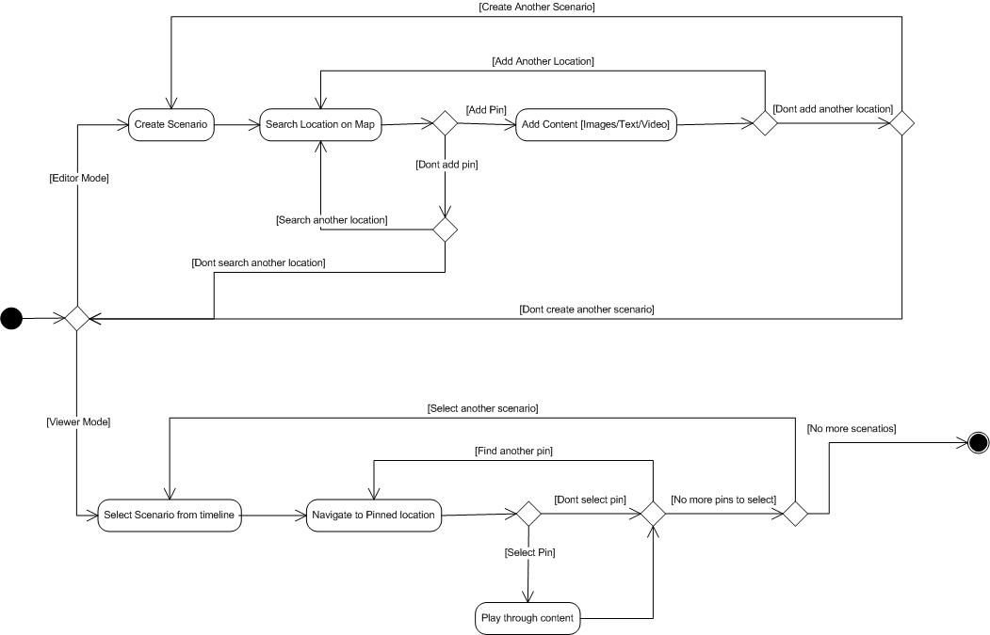

**Software Technologies:**

The History module has been created with a blend of software technologies. The basic application runs on WPF where the Microsoft Kinect SDK is integrated. A WPF web browser control is added here which invokes JavaScript whenever required on the webpage. The webpage uses the AJAX control of Virtual Earth 6.3 to display the map and perform specific tasks whenever Kinect events are fired from WPF.

### Features explanation:

**NUI features:** Kinect’s gesture recognition will be completely integrated within this module, allowing full control using the NUI for the user. The user will be able to perform all the required actions such as panning, zooming, interacting using hand gestures. To show the contents on individual markers the user can hold the cursor above the marker for some time and performs a click action. The user can show different media contents using swipe gesture.

### Challenges faced

The major challenge of this module was showing the Bing Map Birdeye or Streetside View or 3D Bing Map and integrating them with MS Kinect sensor. We tried several options that failed. Firstly, we used the Bing Map WPF control v1 which was recently released in January 2012. But currently features likeStreetside and Birdeye view are not available in it. Then we used Bing Map Silverlight Control to make an Out of Browser application but that doesn’t let you add the Kinect SDK to it.

### Solutions to the challenges faced:

Finally, we have successfully achieved this task using the technologies already mentioned above in software technologies section.

Screenshot: refer to appendix A

## Module E) *Math Module*

Overview:*This part of our application lets the students to experiment with mathematics and takes the traditional form of learning mathematics from bookish stuff to a more practical level where they can play around with the values to get hold of various topics. Topics like equation of a straight line, can be comprehended in a more intuitive way by manipulating numerical values and observing its effects visually on a graph.*

### Technical Details:

**Implementation:**

The math module has two basic features:

1. **Straight Line Equation**

It helps in explaining the basics of straight line equation such as the gradient/slope and the y-intercept in the equation of the form: y = mx + c.

The user can select this option and controls a line i.e. change its gradient or y-intercept by tilting and moving his hands. The line is formed with coordinates of the hands. The changing values of m (gradient) and c (y-intercept) are shown continuously in the equation. In this way the students can easily understand when the slope becomes negative or positive, or how it increases or decreases.

1. **Graph Drawing**

This portion of our application is not fully implemented yet. But the idea is to show graphs of complex equations. The equations will be given by the user and a plot of that equation is shown in runtime. We are planning to use the Wolfran library for this purpose but at this moment nothing can be said about how it will get implemented.

## Novelty/Commercial Viability:

Our solution is not only aimed for educational institutes of our country, but at educators and schools world over, aiming to make education more interesting and effective as well as easy for them to teach side by side. We plan to market our product as a shareware, enabling institutes and individuals the world over to utilize it and reap its benefits. For institutes that are willing to take the experience up a notch, they can purchase a license from us, for full technical support. They may also have the software customized and have custom modules built to suit their specific needs for an appropriate fee.

From the consumer point of view, the cost one has to bear to fully implement our solution is of a Microsoft Kinect, and a computer capable of running Microsoft Windows.Meeting these cost requirements won’t be a hassle for many of the institutes, and even if it is for some, this cost can be easily overcome through government support, NGO’s and charities working for the cause of education.

The following points highlight some facts as far as Novelty and commercial viability is concerned.

* While some alternative, surface-based computing solutions do exist, but majority of them are either too expensive or too difficult to deploy on a mass scale.
* To our knowledge before the availability of kinect, No cheap, commercial or viable hardware existed that could offer similar capabilities as that of kinect.The fact that we are making use of newly available, affordable and marketable technology makes our solution both businesses viable and unique.
* Although we might be expecting some market competition in the future, still we are skeptic about the field of education, which has been previously been left out in the dark as far as technological advancement is concerned! Thus making our product a worthy competitor in the open market.

## Conclusion:

* Education sector is yet to realize the full potential of modern technology.
* Low cost solutions like ours can solve problems that low budget institutes like Govt. School and College Taxila and others in our country face.
* NUI is the way forward of interacting with computers.Our application shows various possibilities of gesture based computing in classrooms, which can provide an exciting interactive educational experience.

# Appendix-A

## Project Screenshots:

### *Chemistry Module:*

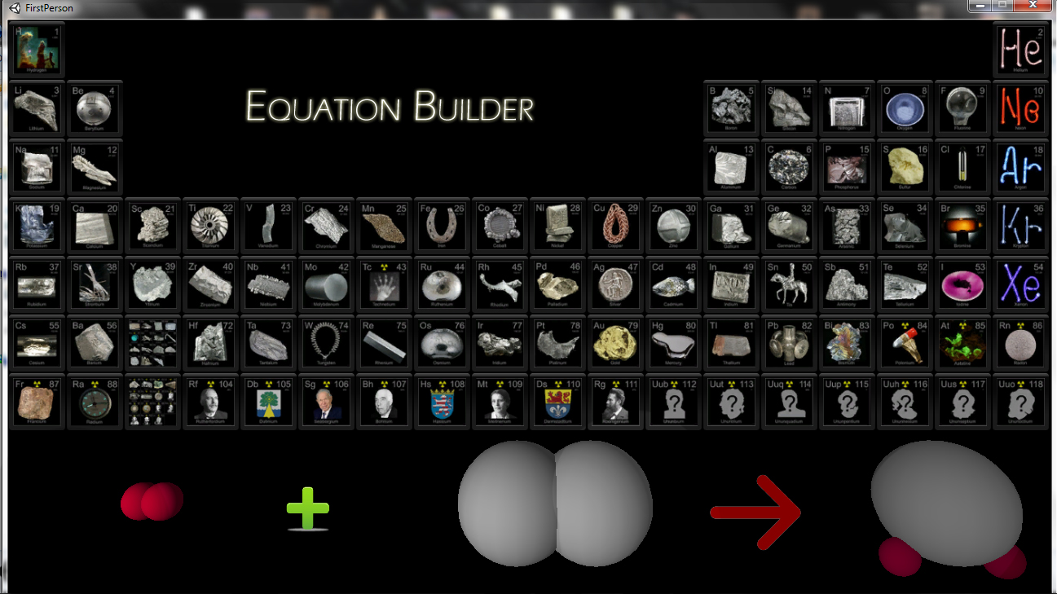

*Teacher can visually teach the making of a compound using the chemical equation builder. Instead of writing symbols on the white board he can visually show the 3D outlook of an atom or molecule. In the module snip the sphere represent the elements, which can be dragged upon the screen from the periodic table to create an equation. The generic modeling feature of this software allows its user to create any equation from the elements present in the periodic table.*

# *Physics Module:*

*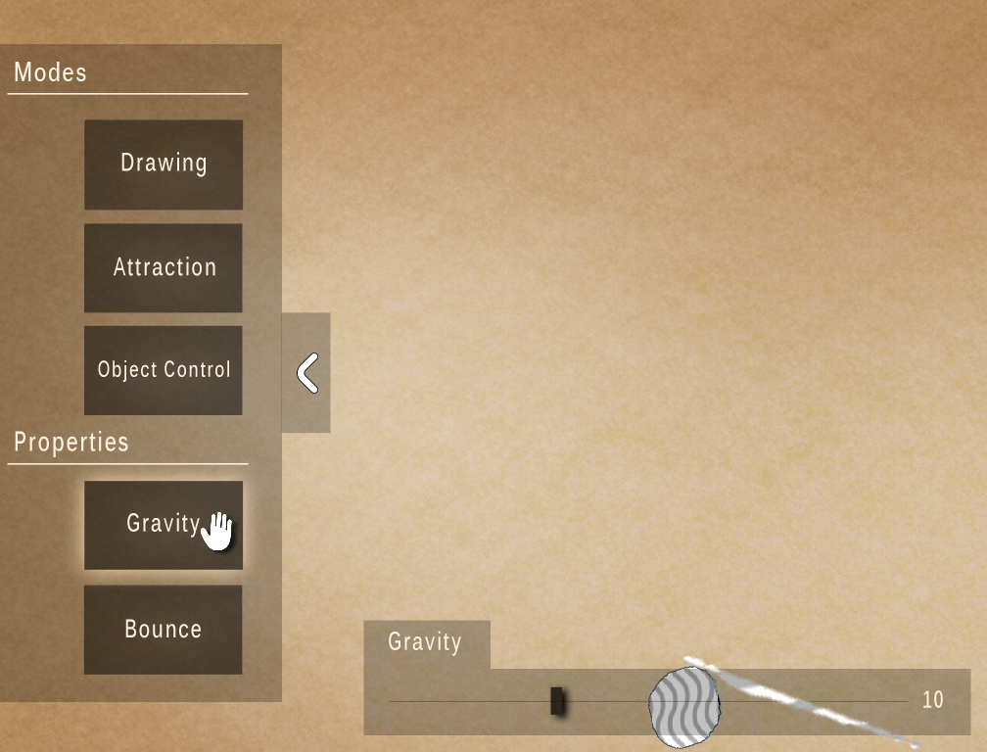This app is used to visually teach student the different concepts of physics. The students get to feel and experiment for themselves the effects of gravity, magnetism, bounce, object manipulation etc. The interface allows students to select certain modes and then experiment by allowing their creativity to run free. For example in gravity mode, objects can be drawn and the effect of gravity on them can be seen. Students have to option to alter gravity values and experience themselves its effect on the on-screen object.*

# *History learning App:*

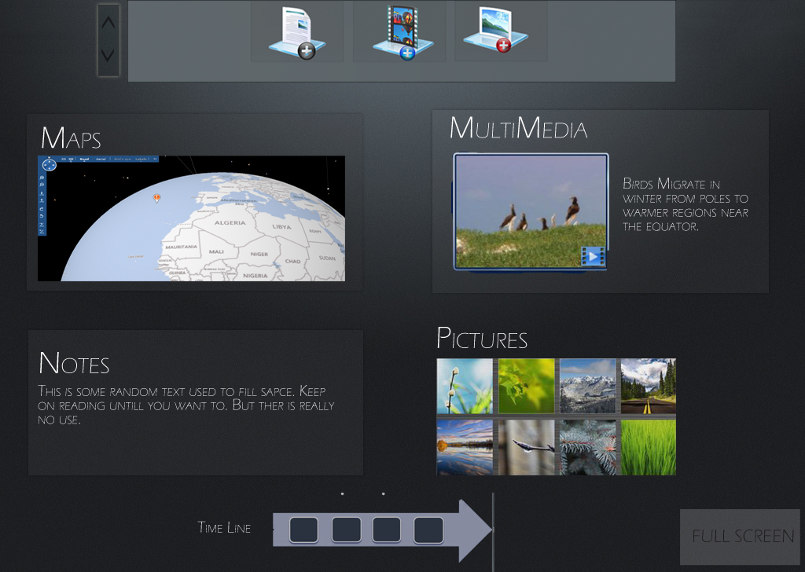

*The Students learn a history lesson in a much more intuitive way. Students can visually see the world locations under study using an interactive 3D map. Teacher has the option to add multimedia content and notes about certain pinned locations to create a complete lesson. He can also navigate back and forth in time using a time line. The whole process of visual illustrations will make the history class much more fun and exciting than just reading off facts and figures from a plain text book.*

### References:

### Pre-existing source code files or third-party binary libraries:

1. Farseer Physics Engine (under Microsoft Permissive License (Ms-PL)) is used for the Physics module. For more details the following link can be visited: <http://kinecttoolbox.codeplex.com>.
2. Kinect Toolbox v1.1.0.2 (under Microsoft Permissive License (Ms-PL)) will be used for some of the gestures’ recognition. For more details the following link can be visited: <http://kinecttoolbox.codeplex.com>.
3. KinectSDK / Unity3D Interface v.3.0 is used to link the 3D content with Microsoft Kinect SDK Beta 2. Creator: Andrew DeVine from University of Central Florida ISUE Lab. For more details the following link can be visited: <https://github.com/adevine1618/KinectSDKUnity3D_Interface_Plugin#readme>.
4. Unity 3D Free Version is used for creation and manipulation of 3D Models. For more details and license the following link can be visited: <http://en.wikipedia.org/wiki/Unity_%28game_engine%29#Licensing>.

### Research Papers:

*Real-Time Human Pose Recognition in Parts from Single Depth Images by Jamie Shotton Andrew Fitzgibbon Mat Cook Toby Sharp Mark Finocchio Richard Moore Alex Kipman Andrew Blake*

*Microsoft Research Cambridge & Xbox Incubation.*

### Web

Microsoft Research

www.research.microsoft.com

Research at Intel Labs Seattle

**RGB-D: Techniques and usages for Kinect style depth cameras**

http://ils.intel-research.net/projects/rgbd